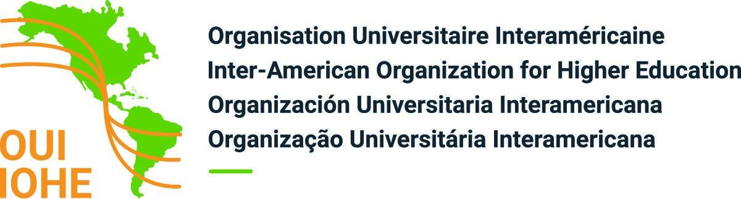

MEMBERSHIP APPLICATION FORM

Universities/institutions of higher education and research centers

Date of
1. Name of institution foundation:

2. Address

3. Telephone _ Fax WWW

4. President, Rector, Chancellor or Principal (specify function)
Duration of mandate :
from_____ to ______

Office:
Telephone _ Fax E-mail

5. Type of institution: university, college, technological institute, research centre (other: please specify)

6. Legal status of institution:
public national ___ provincial / state ___ single campus
private multicampus

7. Undergraduate and graduate degree programs offered by your institution (please list major programs):

Degrees awarded: Bachelor’s Master’s Doctorate
Number of degrees awarded in each category, in each of the past two years:
Year 20___ : Bachelor’s Master’s Doctorate
Year 20___ : Bachelor’s Master’s Doctorate

(verso)

8.a) University and institution of higher education
Number of students: full-time part-time

Academic staff: full-time part-time

b) Research Center
Number of researchers: full-time part-time

Number of students: full-time part-time

Academic staff: full-time part-time

9. National, regional and international higher education association of which your institution is a member:

10. Officer responsible for international cooperation programs:

Name

Function

Telephone _ Fax E-mail

Signature

Date
(name and function in capital letters)

Please send e-mail to sec.general@oui-iohe.org and/or mail the original to:

Inter-American Organization for Higher Education
7077 Avenue du Parc, suite 2043
Montréal, Qc, Canada
H3N 1X7

Please enclose substantiating documentation on your legal status and
send us a brochure on your institution showing your programs and development plan
or let us know if the information is available on your website.

